The SELECT Statement:

Problem
Electricity_Bill Select Queries - Oracle

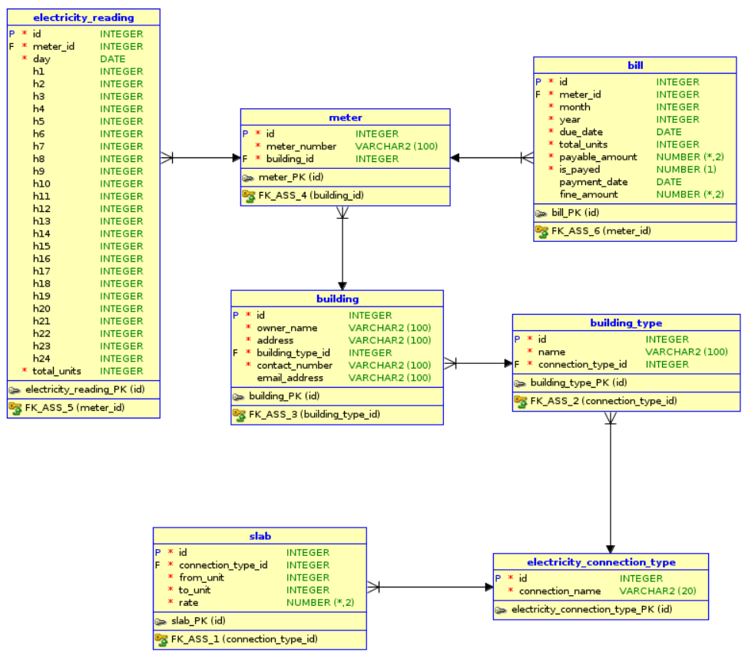

Q 1. Write a query to display the entire contents of the 'electricity_connection_type'. Display the records in ascending order based on their connection name.
Ans:
SELECT * FROM electricity_connection_type ORDER BY connection_name;

Q 2. Write a query to display the owner_name and contact_number of all building, Display the records in ascending order based on owner_name.
Ans:
SELECT owner_name, contact_number FROM building ORDER BY owner_name;

Q 3. Write a query to display the details of all the bills whose 'total_units' greater than 10000, sorted by total_units in descending order.
Ans:
SELECT * FROM bill WHERE total_units > 10000 ORDER BY total_units DESC;

Q 4. Write a query to display the 'rate' of slab whose from_unit is 2001 and to_unit is 4500.
Ans:
SELECT rate FROM slab WHERE from_unit BETWEEN 2001 AND 4500;

Q 5. Write a query to display the owner_name, address and contact_number of the buildings which does not have an email_address. Display the records in ascending order based on their owner_name.
Ans:
SELECT owner_name, address, contact_number FROM building WHERE email_address IS NULL ORDER BY owner_name;

ACCESS :

Q 1. Write a query to display all the details of the 'station' which does not have any interchanges.Display the records in ascending order based on the 'name'.
Ans:
SELECT * FROM station WHERE is_interchange = 0 ORDER BY name;

Q 2. Write a query to display all the details of the travel_card in which the name of person is 'Michael'.
Ans:
SELECT * FROM travel_card WHERE person_name = 'Michael';

